**DAILY ONLINE ACTIVITIES SUMMARY**

|  |  |  |  |  |  |  |  |  |
| --- | --- | --- | --- | --- | --- | --- | --- | --- |
| **Date:** | **03/06/2020** | | | | | **Name:** | **PONICA.J** | |
| **Sem & Sec** | **4TH & B** | | | | | **USN:** | **4AL18CS055** | |
| **Online Test Summary** | | | | | | | | |
| **Subject** | | **OOC** | | | | | | |
| **Max. Marks** | | **30** | | **Score** | | | **13** | |
| **Certification Course Summary** | | | | | | | | |
| **Course** | **PYTHON IN DATA SCIENCE** | | | | | | | |
| **Certificate Provider** | | | **COGNITIVECLASS** | | **Duration** | | | **5HOURS** |
| **Coding Challenges** | | | | | | | | |
| **Problem Statement:** You have to find the last digit of a^b.   |  | | --- | |  | |  | |  |  |  | | --- | |  | |  | |  | | | | | | | | | |
| **Status:EXECUTED** | | | | | | | | |
| **Uploaded the report in Github** | | | | | **YES** | | | |
| **If yes Repository name** | | | | | **https://github.com/ponica-jaya/LOCKDOWN-CODING.git** | | | |
| **Uploaded the report in slack** | | | | | **YES** | | | |

Online Test Details: (Attach the snapshot and briefly write the report for the same)

TODAY (03/06/2020) I HAD TEST ON THE SUBJECT OOC FROM 9.15 TO10.00AM WHICH HAD 30 MCQ CODING PROBLEMS TO SOLVE AND I HAVE ATTACHED MY TEST DETAILS SNAPSHOT.

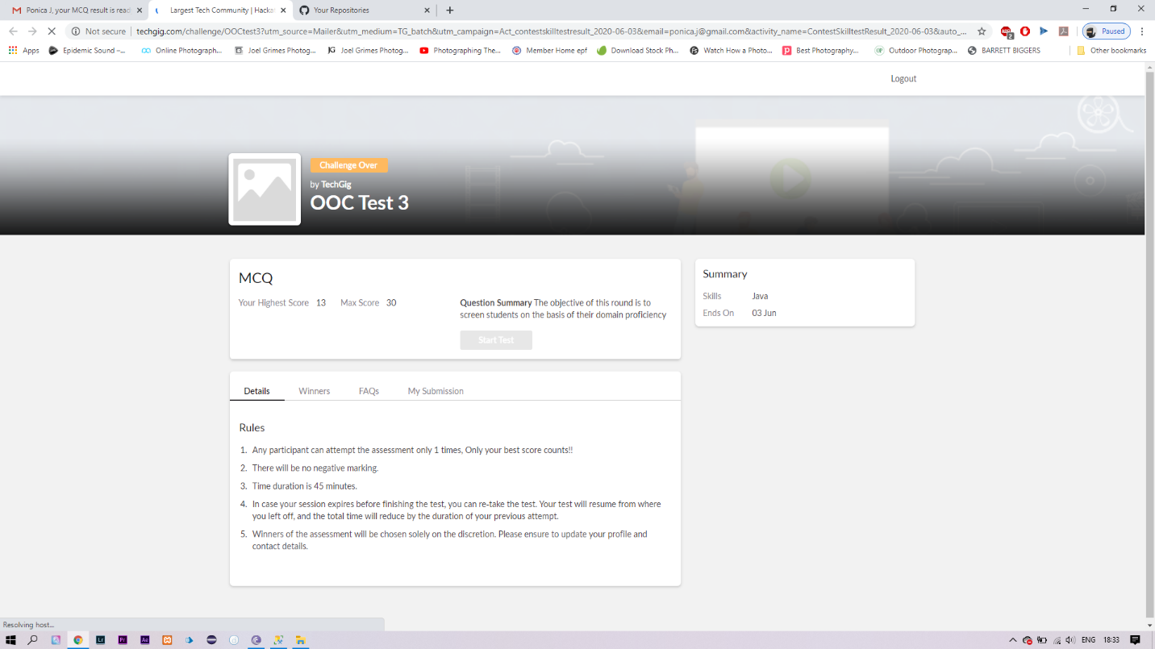

Certification Course Details: (Attach the snapshot and briefly write the report for the same)

PYTHON DATA USED FOR EVERYTHING FROM IMPORTING DATA FROM EXCEL SPREADSHEETS TO PROCESSING SETS FOR TIME-SERIES ANALYSIS

THE BELOW IS SNAPSHOT OF MY CERTIFICATION COURSE.

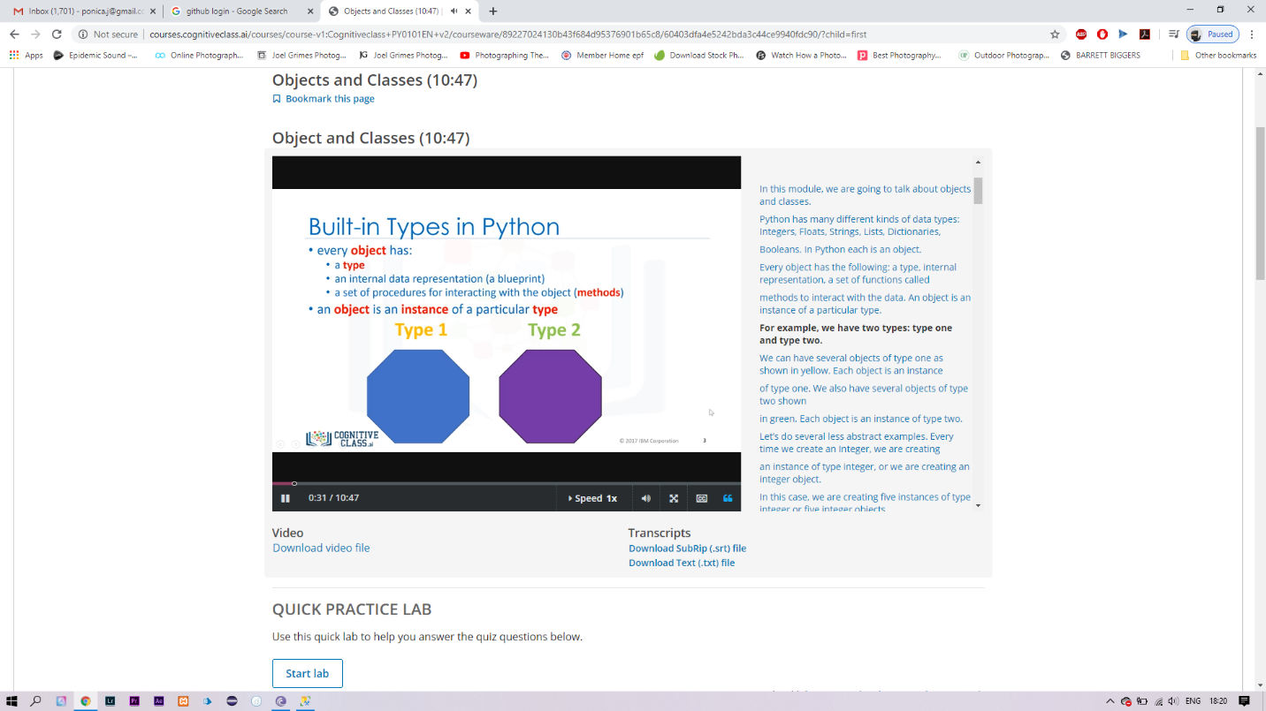

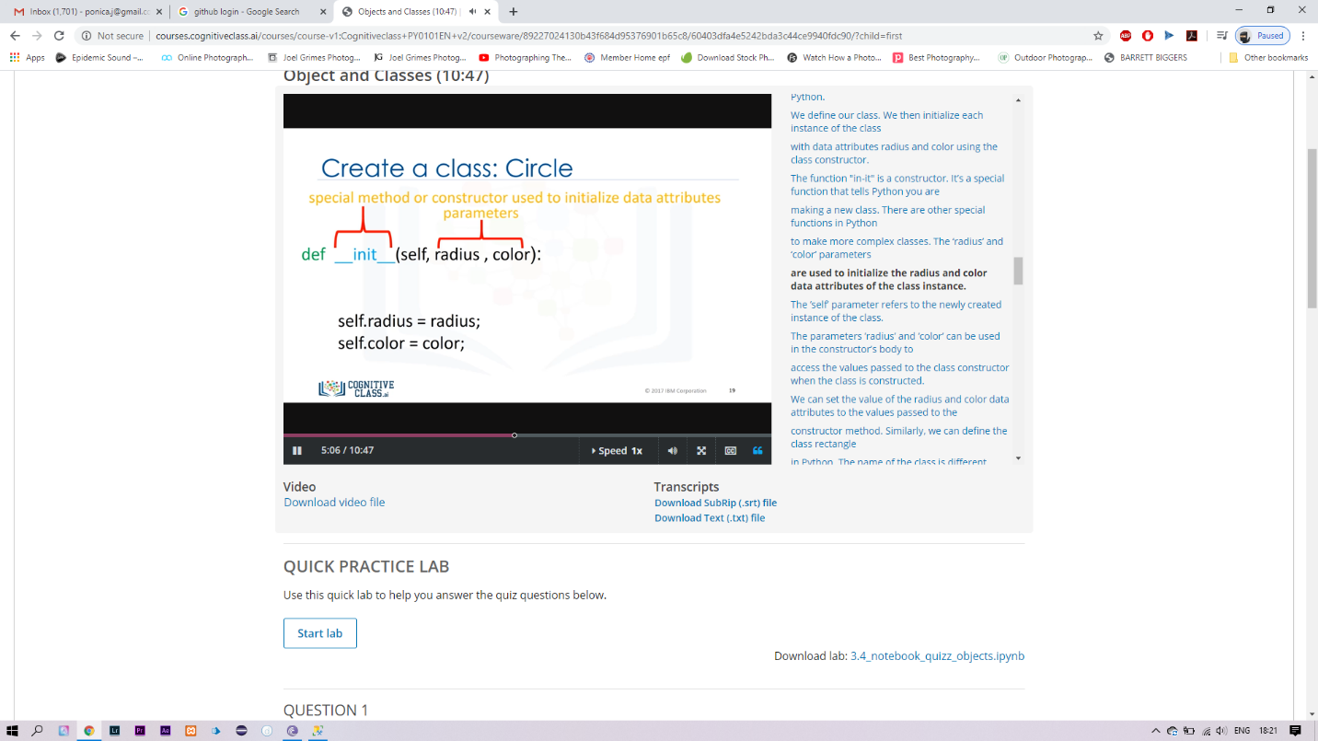

Coding Challenges Details: (Attach the snapshot and briefly write the report for the same)

You are given two integer numbers, the base a (number of digits d, such that 1 <= d <= 1000) and the index b (0 <= b <= 922*10^15). You have to find the last digit of a^b.

Examples:

Input : 3 10  
Output : 9

Input : 6 2  
Output : 6

Algorithm  
Algorithm :

1. Since number are very large we store them as a string.
2. Take last digit in base a.
3. Now calculate b%4. Here b is very large.  
   -> If b%4==0 that means b is completely divisible by 4, so our exponent now will be exp = 4  
   because by multiplying number 4 times, we get the last digit according to cycle table in  
   above diagram.  
   ->If b%4!=0 that means b is not completely divisible by 4, so our exponent now will be  
   exp=b%4 because by multiplying number exponent times, we get the last digit according to  
   cycle table in above diagram.  
   -> Now calculate digit = pow( last_digit_in_base, exp ).  
   ->Last digit of a^b will be ldigit%10.

SOLUTION:THE GIVEN PROBLEM IS SOLVED AND UPLOADED IN MY GITHUB ACCOUNT AND BELOW I HAVE ATTACHED A SNAPSHOT OF THE PROGRAM

